Software Requirements Specification
Project Title: Vocal-Dine AI Powered Voice‑Interactive Smart Menu System


Submitted by:
Alishba Abbas
Roll No: S25BINFT7M04035
Submitted to:
Dr Professor Dost Muhammad khan
Supervisor, Department of Information Technology
Department of Information Technology
Faculty of Computing
The Islamia University of Bahawalpur
Academic Year 2025-2027

Summary
This Software Requirements Specification (SRS) document defines the complete functional and non-functional requirements for the Vocal-Dine system, developed as a Final Year Project by Alishba Abbas under the supervision of Dr. Professor Dost Muhammad Khan at The Islamia University of Bahawalpur. Vocal-Dine is an AI-powered voice-interactive smart menu system designed for the hospitality
industry. It replaces traditional printed menus with a web-based interface that allows customers to scan a QR code and place orders using natural voice commands. The system utilizes React.js for the frontend, Flask for the backend, Firebase for real-time data management, and Scikit-Learn for NLP-driven smart suggestions. This document covers the purpose, scope, technical architecture, and detailed use cases of the system. Vocal-Dine ensures a seamless ordering experience. This document provides a deep dive into the system&#39;s
architecture, user roles, technical constraints, and specific use cases to ensure robust implementation baseline.

Table of Contents
- 1. Introduction
- 1.1 Purpose
- 1.2 Scope
- 1.3 Product Perspective
- 1.4 User Characteristics
- 1.5 Similar Apps and Systems / Literature Review
- 1.6 Proposed Technologies
- 2. Requirements
- 2.1 Functional Requirements
- 2.2 Non‑Functional Requirements
- 3. Use Cases and Flow of Processes
- 3.1 System Level Use Case Diagram
- 3.2 Use Case Example
- 4. Diagrams
- 4.1 Activity Diagram
- 4.2 ER Diagram
- 4.3 UI Diagram
- 5. References
Introduction
In today’s modern world, restaurants are moving towards digital systems to improve customer experience. Traditional ordering methods, such as printed menus and waiting for waiters, can be slow and sometimes confusing for customers. These methods also create problems for elderly people or visually impaired users who may find it difficult to read menus.
With the help of Artificial Intelligence (AI) and voice technology, it is now possible to create smarter and faster systems. Voice-based systems allow users to interact naturally by speaking instead of clicking or reading long menus .The proposed system, Vocal-Dine, is a web-based smart menu system that allows customers to view menus, get food suggestions, and place orders using voice commands. This system aims to make the dining process faster, easier, and more interactive for users, while also helping restaurants manage orders efficiently.

1.1. Purpose
The purpose of this document is to clearly explain how the Vocal-Dine system will work. It describes all the requirements, features, and system behavior in detail.
This document will:
- Explain what the system will do
- Help in understanding system design and development
- Provide a clear guide for evaluation and testing
- Act as a reference for the supervisor and student

1.2. Scope
Vocal-Dine is a web-based application designed for restaurants and cafes.
The system will allow customers to:
- Scan a QR code to open the menu
- Use voice commands to explore food items
- Place orders using voice
- Receive suggestions based on preferences
The system will allow administrators to:
- Manage customer orders
- View sales and analytics
- Monitor popular items
Out of Scope:
- Cooking or kitchen automation
- Delivery system integration
- Mobile apps (Android/iOS)

1.3. Product Perspective
Vocal-Dine is a standalone system that combines multiple technologies into one platform.
It includes:
- A frontend interface where users interact
- A backend server that processes requests
- A voice recognition system that understands user speech
- A database to store orders and user data
All parts of the system are connected and communicate with each other using APIs.

1.4. User Characteristics
The Vocal-Dine system is designed for multiple types of users, each having different roles, responsibilities, and levels of technical knowledge. Understanding these user groups helps in designing a system that is easy to use, efficient, and suitable for real-world restaurant environments.

Customer Side (End Users)
Customers are the primary users of the system. These include people visiting restaurants such as students, families, professionals, and general users. Some users may also include elderly individuals or visually impaired persons who may find traditional menus difficult to use.
Customers are expected to have basic knowledge of using smartphones or web browsers. They do not need any technical background because the system is designed to be simple and user-friendly. The main interaction of customers with the system is through voice commands and simple touch actions.
Customers will:
- Scan a QR code to access the menu
- Use voice commands to browse food items
- Place orders using speech
- Receive suggestions and confirmations
The system assumes that users can speak simple and clear commands like “show burgers,” “order pizza,” or “recommend something.” The interface should guide users properly, especially first-time users, and provide feedback for every action.
Special attention is given to accessibility so that users who cannot read properly can still interact easily using voice.

Admin Side (Restaurant Staff)
The admin users are restaurant staff members who manage the system from the backend. Their main responsibility is to handle customer orders and monitor restaurant activity through the dashboard.
Admins are expected to have basic computer knowledge, such as using a web interface and understanding simple data like order lists and graphs. They are not required to have any technical knowledge of AI or system development.
Admins will:
- View incoming orders in real-time
- Accept or reject orders
- Monitor order status
- View analytics such as sales trends and popular items
The system should provide a clean and organized dashboard so that admins can quickly understand and manage tasks without confusion. Information should be displayed clearly to avoid errors in order handling.

System Side (System Behavior & Role)
The system itself acts as an intelligent intermediary between customers and the restaurant. It is responsible for processing user inputs, managing data, and ensuring smooth communication between all components.
The system performs the following roles:
- Captures and processes voice input using speech recognition
- Converts speech into text and identifies user intent
- Manages menu display and order processing
- Stores user and order data in the database
- Provides real-time updates to both customer and admin
- Generates recommendations based on user behavior and trends
The system is expected to operate automatically without manual intervention. It should handle multiple users at the same time, provide fast responses, and ensure accuracy in order processing.It should also handle errors properly, such as unclear voice input or system delays, by providing user-friendly messages and fallback options.
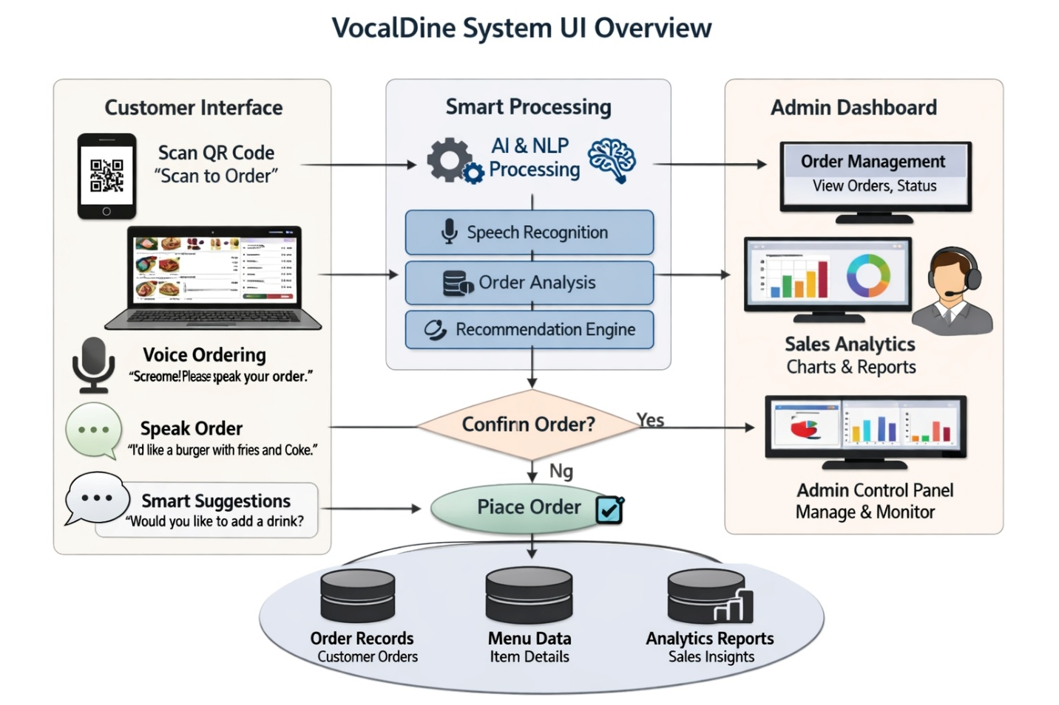

1.5. Similar Systems and Literature Review
A review of existing systems shows that many digital solutions have been developed to improve customer experience in restaurants, but most of them lack full integration of voice interaction, intelligent recommendations, and real-time analytics in a single platform.
One common solution is the use of QR code-based digital menus, which became popular after the COVID-19 pandemic. These systems allow customers to scan a QR code and view the menu on their mobile devices. While they reduce physical contact and improve convenience, they are mostly static and require manual browsing. They do not provide voice interaction or personalized recommendations, which limits user engagement and accessibility.
Another related system is the use of voice assistants such as Google Assistant, Alexa, and Siri. These systems allow users to interact using voice commands and perform tasks such as searching information or controlling devices. However, these assistants are general-purpose and are not specifically designed for restaurant environments. They do not support structured menu navigation, real-time order management, or restaurant-specific analytics.
In addition, many online food ordering platforms provide recommendation systems based on user preferences and past orders. These systems use basic Artificial Intelligence techniques to suggest items, but they rely heavily on manual input and clicking. They do not provide real-time voice-based interaction, which makes the process less natural and less accessible for some users.
From a research perspective, studies in the field of Natural Language Processing (NLP) and Human-Computer Interaction (HCI) have shown that voice-based systems can significantly improve usability, especially for users with accessibility needs. Voice interfaces reduce the effort required to navigate complex menus and provide a more natural way of interaction.
The proposed system, Vocal-Dine, improves upon these existing solutions by combining multiple technologies into a single integrated platform. It provides voice-based menu navigation, AI-driven food recommendations, real-time order processing, and an analytics dashboard for administrators. This combination makes the system more interactive, efficient, and user-friendly compared to traditional digital menu systems.

1.6. Proposed Technologies
The system shall be implemented using the following technology stack:
Category | Technology | Purpose
Frontend | React | User interface
Backend | Python (Flask) | System logic
Database | Firebase | Store data
AI/Voice | Web Speech AI | Speech recognition
Analytics | Chart.js | Analytics

2. Requirements
The Vocal-Dine system is designed to provide a complete and intelligent restaurant ordering solution using voice interaction and web technologies. The system must handle user input, process voice commands, manage orders, and provide analytics in a smooth and efficient manner.
The system will support real-time interaction between customers and restaurant staff. It should be able to process multiple requests at the same time while maintaining accuracy and speed. The requirements of the system are divided into two main categories: functional requirements and non-functional requirements.

2.1. Functional Requirements

2.1.1. QR Code Menu Access
Field | Description
Name | FR001
Purpose | The system shall allow customers to access the menu by scanning a QR code.
User(s) | Customer
Input | QR code scan using mobile device
Output | Menu interface displayed in browser
Pre-condition | Valid QR code must be available
Post-condition | User is able to view and interact with the menu
Post-condition | User is able to view and interact with the menu

2.1.2 Voice Command Processing
Field | Description
Name | FR002
Purpose | The system shall allow users to interact using voice commands.
User(s) | Customer
Input | Voice input via microphone
Output | Converted text and system response
Pre-condition | Microphone access enabled
Post-condition | User command is processed successfully
Error Conditions | Unclear speech or noise → ask user to repeat

2.1.3. Food Ordering System
Name | FR003
Purpose | The system shall allow customers to place food orders.
User(s) | Customer
Input | Voice command (e.g., “Order pizza”)
Output | Order confirmation displayed
Pre-condition | Menu must be loaded
Post-condition | Order stored and sent to admin panel
Error Conditions | Item not found → display message

2.1.4. AI-Based Recommendation System
Name | FR004
Purpose | The system shall provide smart food recommendations.
User(s) | Customer
Input | User preferences and selections
Output | Suggested food items
Pre-condition | Menu data available
Post-condition | Recommendations displayed
Error Conditions | No data → show popular items

2.1.5. Order Management (Admin Panel)
Name | FR005
Purpose | The system shall allow admins to manage orders.
User(s) | Admin
Input | Incoming customer orders
Output | Updated order status
Pre-condition | Admin logged in
Post-condition | Order processed successfully
Error Conditions | System delay → retry or refresh

2.1.6. Analytics Dashboard
Name | FR006
Purpose | The system shall provide analytics to admin.
User(s) | Admin
Input | Order and sales data
Output | Graphs and reports
Pre-condition | Data available
Post-condition | Insights displayed
Error Conditions | No data → show empty state

2.2. Non-Functional Requirements
Non-functional requirements define how well the Vocal-Dine system performs its operations. These requirements focus on system quality, performance, security, and usability. They ensure that the system is efficient, reliable, and suitable for real-world restaurant environments.

Performance and Response Time
The Vocal-Dine system shall provide fast and responsive interaction to users. All major operations, including voice command processing, menu loading, and order confirmation, should be completed within 2 to 3 seconds under normal conditions.
Voice input should be processed in real-time so that users do not experience delays while interacting with the system. A slow response can negatively affect the user experience, especially in busy restaurant environments where quick service is important.

Scalability
The system shall be able to handle multiple users at the same time without performance issues. As the number of customers increases, the system should continue to operate smoothly without slowing down.
The system should be designed in a way that it can be expanded in the future, allowing more users, more restaurants, or additional features without major changes to the core system.

Security
The Vocal-Dine system shall ensure that all user data and system communication are secure. All data transmitted between the user and the server shall be protected using HTTPS encryption.
User authentication should be handled using secure methods such as JWT (JSON Web Tokens) to prevent unauthorized access. Sensitive information, such as user details and order data, should be stored securely in the database.
The system should also protect against common security threats such as unauthorized access and data leakage.

Usability
The system shall be easy to use for all types of users, including first-time users. The interface should be simple, clean, and well-organized so that users can quickly understand how to interact with the system.
Voice commands should be natural and easy to use, without requiring technical knowledge. The system should provide clear feedback after every user action, such as confirming an order or showing results.
Special attention should be given to accessibility, ensuring that users who have difficulty reading can still use the system through voice interaction.

Reliability
The system shall be reliable and should operate without unexpected failures. It should be able to handle errors properly without crashing.
In case of any issue, such as failed voice recognition or network delay, the system should display clear and helpful error messages and allow the user to try again. This ensures that the user experience is not negatively affected.

Availability
The Vocal-Dine system shall be available whenever the restaurant is operating. Users should be able to access the system at any time during business hours without interruption.
System downtime should be minimized, and the system should remain stable even during peak usage times.

Maintainability
The system shall be designed in a way that it is easy to maintain and update. The code should be well-organized and modular so that developers can make changes or add new features without affecting existing functionality.
This will allow future improvements such as adding new features, improving AI models, or integrating additional services.

Compatibility
The system shall be compatible with different devices and web browsers. It should work smoothly on mobile phones, tablets, and desktop computers.
The user interface should be responsive, meaning it should automatically adjust to different screen sizes. The system should also support commonly used browsers such as Chrome and Edge.

3. System Architecture Overview
The Vocal-Dine system follows a multi-layered architecture that separates different functionalities into independent components. This design makes the system more organized, scalable, and easy to maintain. Each layer of the system has a specific role, and all components work together to provide a smooth and real-time user experience.
The architecture is designed to handle user interaction, voice processing, data management, and communication between the customer and the restaurant efficiently.

3.1 Overview of Architecture
The system is mainly divided into four major layers:
- Presentation Layer (Frontend)
- Application Layer (Backend)
- Voice Processing Layer
- Data Layer (Database)
Each layer communicates with the others through well-defined APIs, ensuring proper data flow and system performance.

3.2 Presentation Layer (Frontend)
The Presentation Layer is the part of the system that users directly interact with. It is developed using React.js and provides a responsive and user-friendly interface.
For customers, this layer displays:
- Menu items
- Voice interaction interface
- Order confirmation messages
For administrators, it provides:
- Dashboard view
- Order management interface
- Analytics and reports
The frontend is responsible for capturing user actions such as button clicks and voice input and sending them to the backend for processing. It also displays the results received from the backend in a clear and understandable way.

3.3 Application Layer (Backend)
The Application Layer acts as the core of the system. It is implemented using Flask (Python) and is responsible for handling all business logic.
This layer performs the following tasks:
- Processes user requests
- Handles order creation and management
- Communicates with the database
- Integrates with the voice processing module
- Generates responses for the frontend
The backend ensures that all operations are performed correctly and that data flows smoothly between different parts of the system.

3.4 Voice Processing Layer
The Voice Processing Layer is one of the most important parts of the Vocal-Dine system. It enables users to interact with the system using voice commands.
This layer uses the Web Speech API to:
- Capture voice input from the user
- Convert speech into text
- Send the processed text to the backend
After receiving the text, the system analyzes it to understand the user’s intent (e.g., browsing menu, placing order). Based on this, the system performs the required action.
This layer makes the system more accessible and provides a natural way for users to interact without manual input.

3.5 Data Layer (Database)
The Data Layer is responsible for storing and managing all system data. The Vocal-Dine system uses Firebase as a real-time database.
This layer stores:
- User data
- Menu details
- Order information
- Analytics data
The database allows real-time updates, meaning that when a customer places an order, it is instantly visible in the admin panel. This ensures fast communication and efficient order handling.

3.6 Communication Flow
All components in the system communicate through APIs. The typical flow of data in the system is as follows:
- User interacts with the frontend (via click or voice)
- Request is sent to the backend
- Backend processes the request
- Data is retrieved or stored in the database
- Response is sent back to the frontend
- Result is displayed to the user
This structured communication ensures that the system remains fast, reliable, and easy to manage.

3.7 System Advantages
The chosen architecture provides several benefits:
- Modularity: Each component works independently
- Scalability: System can handle more users in future
- Maintainability: Easy to update and improve
- Performance: Efficient data flow and quick responses
.
4. Use Cases and Flow of Processes
This section presents formal use case specifications for the primary system interactions identified in the functional requirements. Each use case corresponds to one or more functional requirements and describes the complete flow of events between the actor and the system.

4.1 Use Case Diagram for Customer

Description
This use case diagram represents the interaction between the Customer and the Vocal-Dine system. It shows how a customer uses the system to access the menu, interact using voice commands, and place orders.
The customer first scans a QR code to access the menu. After accessing the system, the user can view menu items and interact using voice commands. The system processes these commands and allows the user to place an order. Once the order is placed, the system provides confirmation and may also suggest recommended items.

Actors
- Customer

Use Cases
- Scan QR Code
- View Menu
- Use Voice Command
- Place Order
- Receive Confirmation
- Get Recommendations

Relationship Explanation
All use cases are directly connected to the Customer, as the customer performs all these actions while interacting with the system.

4.1.1. Customer Level Use-case Diagram:

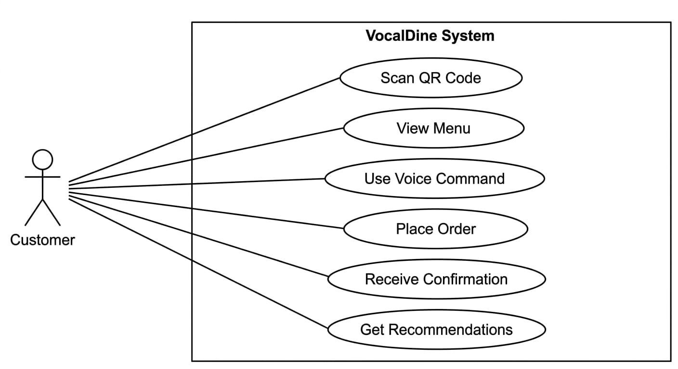

4.2 Use Case Diagram for Admin

Description
This diagram shows how the Administrator (Admin) interacts with the system to manage restaurant operations. The admin is responsible for handling customer orders and monitoring system activity.
The admin logs into the system and accesses the dashboard. From there, they can view incoming orders, manage them by accepting or rejecting, and update their status. The admin can also access analytics to understand sales trends and customer behavior.

Actors
- Admin

Use Cases
- Login
- View Orders
- Manage Orders
- Update Order Status
- View Analytics

Relationship Explanation
All actions are performed by the admin through the dashboard. Each use case is directly connected to the admin actor.

4.2. USER LEVEL USE-CASE DAIGRAM:

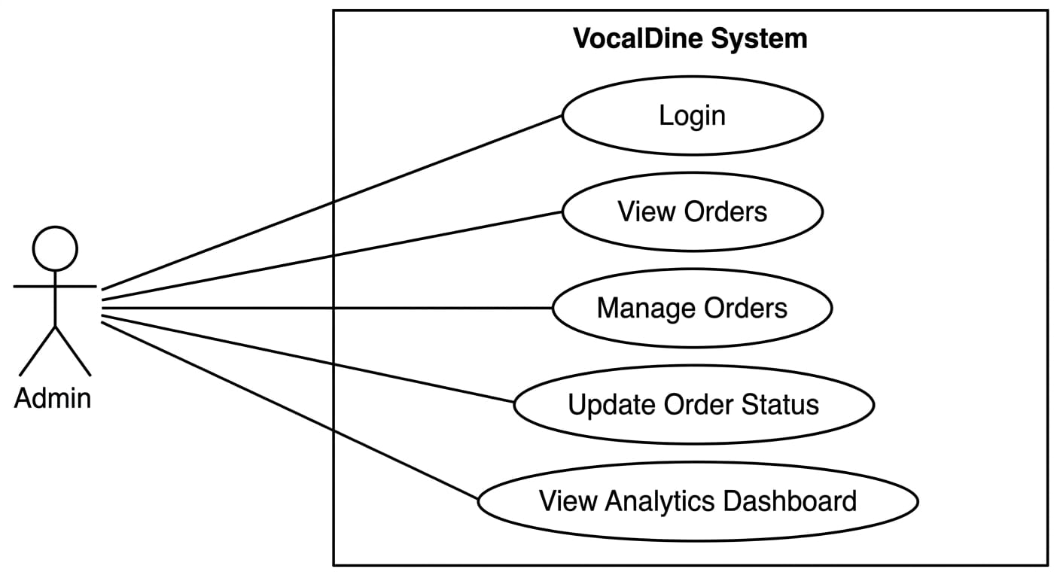

4.3 System Level Use Case Diagram

Description
This diagram provides an overall view of the Vocal-Dine system by showing how both Customer and Admin interact with the system.
The customer interacts with the system by accessing the menu, using voice commands, and placing orders. These actions are processed by the system, which then stores the data and sends the order information to the admin side.
The admin interacts with the system by processing orders and viewing analytics. The system acts as a central unit that manages all data and communication between both actors.

Actors
- Customer
- Admin

Use Cases
- Access Menu
- Voice Interaction
- Place Order
- Process Order
- Store Data
- Display Analytics

Relationship Explanation:
- Customer is connected to:
  - Access Menu
  - Voice Interaction
  - Place Order
- Admin is connected to:
  - Process Order
  - Display Analytics
- The system internally handles:
  - Store Data (central function connecting all processes)
4.3. SYSTEM USE CASE DAIGRAM:

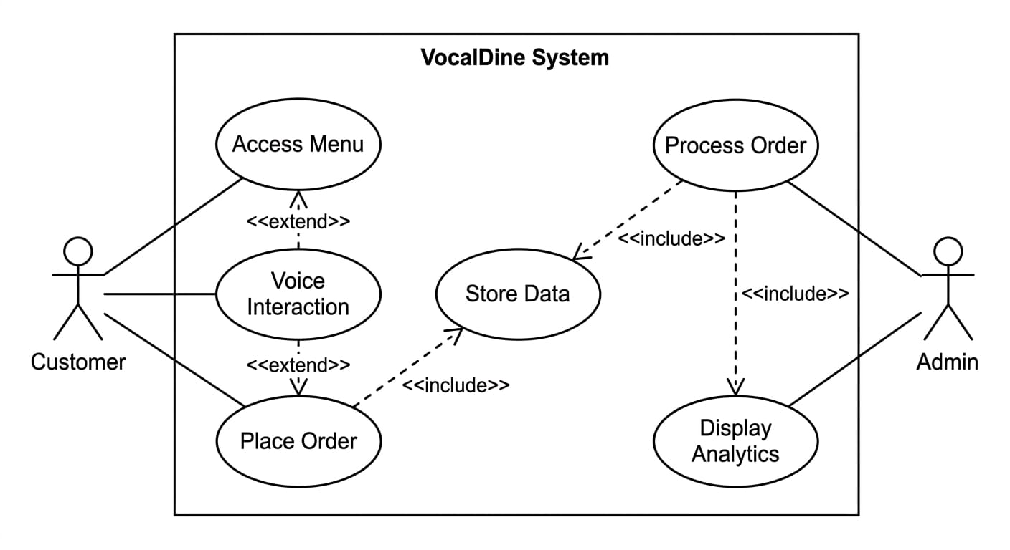

5. References
The following references were used to understand the concepts of voice recognition, web development, artificial intelligence, and modern restaurant systems during the development of the Vocal-Dine project.

Books & Academic Sources:
- Russell, S., & Norvig, P. (2021). Artificial Intelligence: A Modern Approach (4th ed.). Pearson.
→ This book was used to understand basic concepts of Artificial Intelligence and intelligent systems.
- Jurafsky, D., & Martin, J. H. (2023). Speech and Language Processing (3rd ed.). Pearson.
→ Used for understanding Natural Language Processing and speech recognition techniques.

Web Technologies & Documentation:
- Mozilla Developer Network (MDN). (2024). Web Speech API Documentation.
Available at: https://developer.mozilla.org
→ Used for implementing speech-to-text functionality.
- React Documentation. (2024). React Official Guide.
Available at: https://react.dev
→ Used for frontend development and UI design.
- Flask Documentation. (2024). Flask Web Framework.
Available at: https://flask.palletsprojects.com
→ Used for backend development and API handling.

Database & Tools:
- Firebase Documentation. (2024). Firebase Realtime Database Guide.
Available at: https://firebase.google.com
→ Used for database design and real-time data handling.
- Chart.js Documentation. (2024). Chart.js Guide.
Available at: https://www.chartjs.org
→ Used for creating analytics dashboards.

Related Systems & Research:
- Google Research. (2022). Advancements in Speech Recognition Technology.
→ Used to understand modern voice recognition systems.
- Zhao, X., et al. (2021). AI-Based Recommendation Systems in E-Commerce Platforms.
→ Helped in understanding recommendation techniques.
- World Health Organization (WHO). (2020). Digital Solutions in Post-COVID Environments.
→ Referenced for QR-based contactless systems.

